**SOME PASSAGES ALONGWITH THEIR SUMMARIES**

**Original Text**

“What is this thing that has happened to us? It’s a virus, yes. In and of itself it holds no moral brief. But it is definitely more than a virus. Some believe it’s God’s way of bringing us to our senses. Others that it’s a Chinese conspiracy to take over the world. Whatever it is, the coronavirus has made the mighty kneel and brought the world to a halt like nothing else could. Our minds are still racing back and forth, longing for a return to “normality”, trying to stitch our future to our past and refusing to acknowledge the rupture. But the rupture exists. And in the midst of this terrible despair, it offers us a chance to rethink the doomsday machine we have built for ourselves. Nothing could be worse than a return to normality. Historically, pandemics have forced humans to break with the past and imagine their world anew. This one is no different. It is a portal, a gateway between one world and the next. We can choose to walk through it, dragging the carcasses of our prejudice and hatred, our avarice, our data banks and dead ideas, our dead rivers and smoky skies behind us. Or we can walk through lightly, with little luggage, ready to imagine another world. And ready to fight for it.”

**Original Text**

The author mentions the various theories that have been put forth for the origins of the virus. Some talk about it in scientific terms, while others chalk it up to Chinese conspiracy theories. Whatever may be the cause, Arundhati argues that there is no doubt that the virus has significantly altered and shaken the foundations of our world as we know it. Amidst the unfurling of our existing order, we are yearning for a sense of normalcy. However, according to Roy, normalcy shouldn’t be our aim at all. Throughout history, pandemics have forced societies to take note of their systems and its failings. It has forced them out of the stupor of inequality, greed and corruption to a prosperous path. If we pay attention and chose to take action for change. We can take this rupture and treat it as a minor glitch in our trajectory or we can choose to reassess and fight for a better world; it all depends on us

**Original Text**

“The Northern Lights” There are times when the night sky glows with bands of color. The bands may begin as cloud shapes and then spread into a great arc across the entire sky. They may fall in folds like a curtain drawn across the heavens. The lights usually grow brighter, then suddenly dim. During this time the sky glows with pale yellow, pink, green, violet, blue, and red. These lights are called the Aurora Borealis. Some people call them the Northern Lights. Scientists have been watching them for hundreds of years. They are not quite sure what causes them. In ancient times people were afraid of the Lights. They imagined that they saw fiery dragons in the sky. Some even concluded that the heavens were on fire.

**Summary**

The Aurora Borealis, or Northern Lights, are bands of color in the night sky. Ancient people thought that these lights were dragon on fire, and even modern scientists are not sure what they are.

**Original Text**

It is physically impossible for a well-educated, intellectual, or brave man to make money the chief object of his thoughts just as it is for him to make his dinner the principal object of them. All healthy people like their dinners, but their dinner is not the main object of their lives. So all healthy minded people like making money ought to like it and enjoy the sensation of winning it; it is something better than money.

A good soldier, for instance, mainly wishes to do his fighting well. He is glad of his pay—very properly so and justly grumbles when you keep him ten years without it—till, his main mission of life is to win battles, not to be paid for winning them. So of clergymen. The clergyman's object is essentially baptize and preach not to be paid for preaching. So of doctors. They like fees no doubt—ought to like them; yet if they are brave and well-educated the entire object to their lives is not fees. They on the whole, desire to cure the sick; and if they are good doctors and the choice were fairly to them, would rather cure their patient and lose their fee than kill him and get it. And so with all the other brave and rightly trained men: their work is first, their fee second—very important always; but still second.

**Precis Summary:**

Money-making is a common attraction in life. But it cannot be the principal aim of well educated, cultured and brave man. A brave soldier prizes honour and victory more than his pay. A good clergyman is more interested in the moral welfare of his people than his returns. A doctor (good) values the care of his patient far more than his fees. Thus with all the well-educated, intellectual persons, their work is first, money next.

**Original Text**

Home is the young, who known "nothing of the world and who would be forlorn and sad, if thrown upon it. It is providential, shelter of the weak and inexperienced, who have to learn as yet to cope with the temptations which lies outside of it. It is the place of training of those who are not only ignorant, but have no yet learnt how to learn, and who have to be taught by careful individual trail, how to set about profiting by the lessons of teacher. And it is the school of elementary studies—not of advances, for such studies alone can make master minds. Moreover, it is the shrine of our best affections, the bosom of our fondest recollections, at spell upon our after life, a stay for world weary mind and soul; wherever we are, till the end comes. Such are attributes or offices of home, and like to these, in one or other sense or measure, are the attributes and offices of a college in a university.

**Precis Summary**

Home shelters the young who are weak and unexperienced and unable to face the temptations in life. It is a centre of their elementary education and a nursery of sweet affections and pleasant memories. Its magic lasts forever. A weary mind turns to it for rest. Such is the function of a home and in some measure of the university.

**Original Text**

Teaching is the noblest of professions. A teacher has a sacred duty to perform. It is he on whom rests the responsibility of molding the character of young children. Apart from developing their intellect, he can inculcate in them qualities of good citizenship, remaining neat and clean, talking decently and sitting properly. These virtues are not easy to be imbibed. Only he who himself leads a life of simplicity, purity and rigid discipline can successfully cultivate these habits in his pupils.

Besides a teacher always remain young. He may grow old in age, but not in spite. Perpetual contact with budding youths keeps him happy and cheerful. There are moments when domestic worries weigh heavily on his mind, but the delightful company of innocent children makes him overcome his transient moods of despair.

**Precis Summary**

Teaching is the noblest profession. A teacher himself leading a simple, pure and disciplined life can mold the character of the young children and make them neat and good mannered citizens. Besides he remains every young forgetting his own domestic worries in the constant company of the young.

**Original Text**

English education and English language have done immense goods to India, in spite of their glaring drawbacks. The notions of democracy and self-government are the born of English education. Those who fought and died for mother India's freedom were nursed in the cradle of English thought and culture. The West has made contribution to the East. The history of Europe has fired the hearts of our leaders. Our struggle for freedom has been inspired by the struggles for freedom in England, America and France. If our leaders were ignorant of English and if they had not studied this language, how could they have been inspired by these heroic struggles for freedom in other lands? English, therefore, did us great good in the past and if properly studied will do immense good in future.

English is spoken throughout the world. For international contact our commerce and trade, for the development of our practical ideas, for the scientific studies, English-is indispensable "English is very rich in literature," our own literature has been made richer by this foreign language. It will really be a fatal day if we altogether forget Shakespeare, Milton, Keats and Shaw.

**Precis Summary**

Notwithstanding its various defects English education has done great good to India. The ideas of democracy and self-government are its gifts. Nursed on English education the Indian leaders were inspired by the Western thought, culture and freedom struggles. They fought for and won their motherland's freedom. Being spoken thought-out the world English is necessary for interna­tional contact, trade, commerce and science. English is rich in literature; its master mind cannot be neglected.

**Original Text**

When we survey our lives and efforts we soon observe that almost the whole of our actions and desires are bound up with the existence of other human beings. We notice that whole nature resembles that of the social animals. We eat food that others have produced, wear clothes that others have made, live in houses that others have built. The greater part of our knowledge and beliefs has been passed on to us by other people though the medium of a language which others have created. Without language and mental capacities, we would have been poor indeed comparable to higher animals.

We have, therefore, to admit that we owe our principal knowledge over the least to the fact of living in human society. The individual if left alone from birth would remain primitive and beast like in his thoughts and feelings to a degree that we can hardly imagine. The individual is what he is and has the significance that he has, not much in virtue of the individuality, but rather as a member of a great human community, which directs his material and spiritual existence from the cradle to grave.

**Precis Summary**

Being social animals, human beings have their actions and desires bound up with society. In matter of food, clothes, knowledge and belief they are interdependent. They use language created by others. Without language their mental power would not grow. They are superior to beast, because they live in human society. An individual life left alone from birth would grow utterly beast like. So human society and not individuality guides man's material and spiritual existence.

**Original Text**

[A text about Johannes Gutenberg](https://en.wikipedia.org/wiki/Johannes_Gutenberg) – (194 words)

Johannes Gutenberg (1398 – 1468) was a German goldsmith and publisher who introduced printing to Europe. His introduction of mechanical movable type printing to Europe started the Printing Revolution and is widely regarded as the most important event of the modern period. It played a key role in the scientific revolution and laid the basis for the modern knowledge-based economy and the spread of learning to the masses.

Gutenberg’s many contributions to printing are: the invention of a process for mass-producing movable type, the use of oil-based ink for printing books, adjustable molds, and the use of a wooden printing press. His truly epochal invention was the combination of these elements into a practical system that allowed the mass production of printed books and was economically viable for printers and readers alike.

In Renaissance Europe, the arrival of mechanical movable type printing introduced the era of mass communication which permanently altered the structure of society. The relatively unrestricted circulation of information—including revolutionary ideas—transcended borders, and captured the masses in the Reformation. The sharp increase in literacy broke the monopoly of the literate elite on education and learning and bolstered the emerging middle class.

**Summary**

The German Johannes Gutenberg introduced printing in Europe. His invention had a decisive contribution in spread of mass-learning and in building the basis of the modern society.

Gutenberg’s major invention was a practical system permitting the mass production of printed books. The printed books allowed open circulation of information, and prepared the evolution of society from to the contemporary knowledge-based economy.

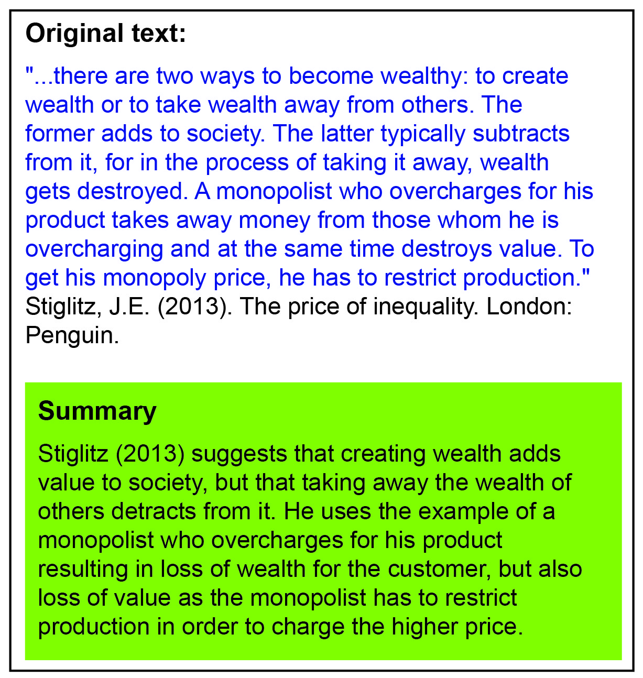

**Original Passage:**

Trees give shade for the benefit of others, and while they themselves stand in the sun and endure the scorching heat, they produce the fruit of which others profit. The character of good men is like that of trees. What is the use of this perishable body if no use is made of it for the benefit of mankind? Sandalwood, the more it is rubbed, the more scent does it yield. Sugarcane, the more it is peeled and cut up into pieces, the more juice does it produce. The men who are noble at heart do not lose their qualities even in losing their lives. What matters do not lose their qualities even in losing their lives. What matters whether men praise them or not? What difference does it make whether they die at this moment or whether lives are prolonged? Happen what may, those who tread in the right path will not set foot in any other. Life itself is unprofitable to a man who does not live for others. To live for the mere sake of living one’s life is to live the life of dog and crows. Those who lay down their lives for the sake of others will assuredly dwell forever in a world of bliss.

**Précis:**

The character of good men is like that of trees. They live for others and do not lose their qualities even in losing their lives. They always follow the even in losing their lives. They always follow the right path. Praise is immaterial to them. To live for one’s own sake is to lead the life of beasts. Only those who lay down their lives for others will live forever in a world of bliss.

*******